BUILDING PERMIT APPLICATION

**City of Medicine Lodge Kansas**

**114 W First Avenue, Medicine Lodge KS 67104**

**Phone: (620)-886-3908 Fax: (620)-886-3900**

**Permit MUST BE POSTED at or near the front of the permitted structure**

|  |  |  |
| --- | --- | --- |
| FEMA # Not Required Other Permit(s) ***#* #** PERMIT #  Zoning: CAMA # Section Twp. Range | | |
| Setback  *Office Use* | Front Side Rear | Payment type: Check # Cash Credit Card  Permit Fee-Based on Labor and Materials: $ |

Value of Project: $

Landowner: Phone:

Email address ______________________________________________________________________________

Worksite Address: City

*Currently Licensed Office verified*

General Contractor Phone: Foundation Phone: Electrician Phone: Plumber Phone: HVAC Phone: Other Phone:

# PROPOSED USE

Single Family Commercial Accessory Structure Ag Building Other

# TYPE OF IMPROVEMENT

|  |  |  |  |  |  |  |
| --- | --- | --- | --- | --- | --- | --- |
| New Home Manufactured Home | | Addition | Remodel | Roof | Siding | Sign |
| Curb Cut | Plumbing | Electrical | | Solar | Sidewalk | |

Other  **Estimated Date work will begin** Work Description: Dimensions: X X

I HEREBY CERTIFY THAT I HAVE READ AND EXAMINED THIS APPLICATION AND KNOW THE SAME TO BE TRUE AND CORRECT. ALL PROVISIONS OF LAWS AND ORDINANCES GOVERNING THIS TYPE OF WORK WILL BE COMPLIED WITH WHETHER SPECIFIED HEREIN OR NOT. I DO HEREBY GRANT THE CITY’S REPRESENTATIVE ACCESS TO THE PREMISES TO DETERMINE COMPLIANCE WITH LOCAL CODES AND ORDINANCES.

ISSUANCE OF A BUILDING PERMIT DOES NOT PRESUME TO GIVE AUTHORITY TO VIOLATE OR CANCEL THE PROVISIONS OF ANY OTHER FEDERAL, STATE, OR LOCAL LAW REGULATING CONSTRUCTION OR THE PERFORMANCE OF CONSTRUCTION.

# Applicant Signature DATE _____________________

# Owner Signature __________________________________________ DATE ______________________

Issued by: Date: **FINALED** By: Date

**PERMIT IS GOOD FOR 180 DAYS FROM THE DATE OF APPROVAL OR LAST INSPECTION**

## EXTENSIONS SHALL BE REQUESTED IN WRITTING

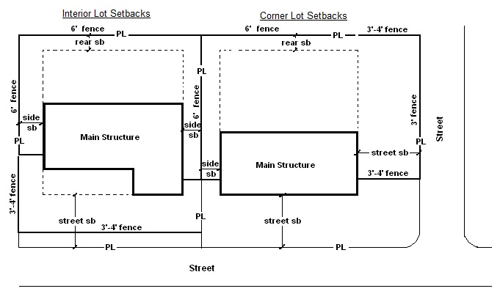

Permits for the construction or modification to a structure, sign, fence etc. require a diagram. Such diagram must indicate the property lines, streets, sidewalks and the placement of any structures or modifications to the property to clearly demonstrate what is being done and where. Arial photographs from applications like google maps are acceptable when applicable property lines are drawn along with setbacks, and locations of structures.

Once approved a building permit will be issued and must be posted at or near the front of the permitted structure and be available for inspection. Once work is completed the permit must be returned to the city hall prior to final inspection. Failure to do so may result in the permit being revoked. A final inspection may be necessary prior to the completion of the project. Questions regarding inspections may be directed to the building inspector.

(ATTACH DIAGRAM OF PROPOSED WORK TO APPLICATION)